Title Page:
Assignment title :
AI-Powered Website Creation using Prompt Engineering.
Teacher Name :
Mam Aleena Aslam
Student Details:
Name : Zain Ali
Roll no : SU92-BSAIM-F25-323
Section: BS AI – 2D
Website Topic:
Travel Agency Website.
Prompt Given to ChatGPT:
Create a modern and attractive travel agency website named "Zain Travels".

The website should have a clean, professional, and user-friendly design with a travel theme (mountains, beaches, airplanes background).

Pages/Sections to include:

1. Home Page:
- Eye-catching banner with travel images
- Tagline: "Explore the World with Zain Travels"
- Short introduction about the agency

2. About Us:
- Information about the company
- Mission and vision
- Why choose us

3. Services:
- Tour packages (local and international)
- Hotel booking
- Flight booking
- Umrah/Hajj packages

4. Packages Section:
- Display 3-6 travel packages with images
- Show price, duration, and details

5. Gallery:
- Beautiful travel images (nature, cities, beaches)

6. Contact Us:
- Phone number
- Email
- Location
- Contact form

7. Booking Form:
- Name
- Email
- Destination
- Travel date
- Submit button

Design Requirements:
- Use soft colors (blue, white, sky theme)
- Add smooth scrolling
- Mobile responsive design
- Add icons and buttons

Extra Features:
- Add testimonials from customers
- Add a "Book Now" button on homepage
- Include footer with social media links

Make the website simple but visually attractive and easy to navigate.
Final Prompt:
I understand 👍 you want to create a travel agency website, and for that you need a strong AI prompt that you can use in a website builder (such as Google Sites, Wix, or any AI tool).
I am giving you a ready-to-use professional prompt 👇
Screenshots:
Screenshot 1:
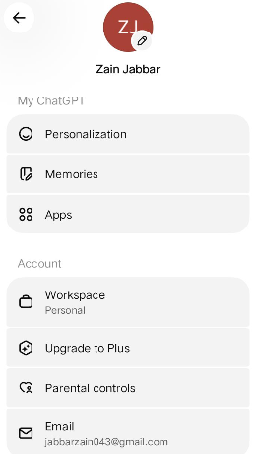
Screenshot 2:
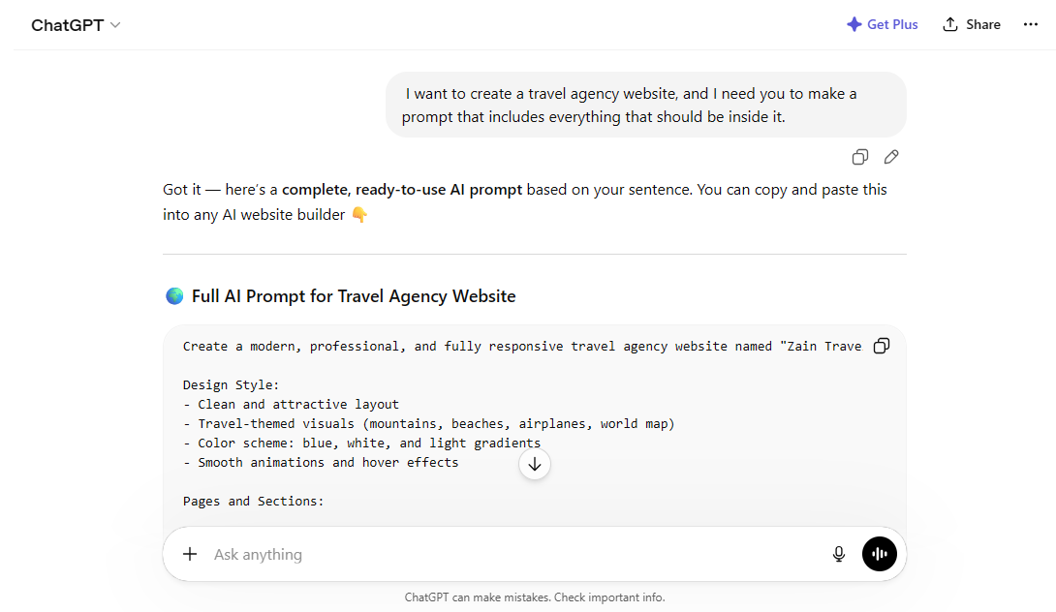
Screenshot 3:
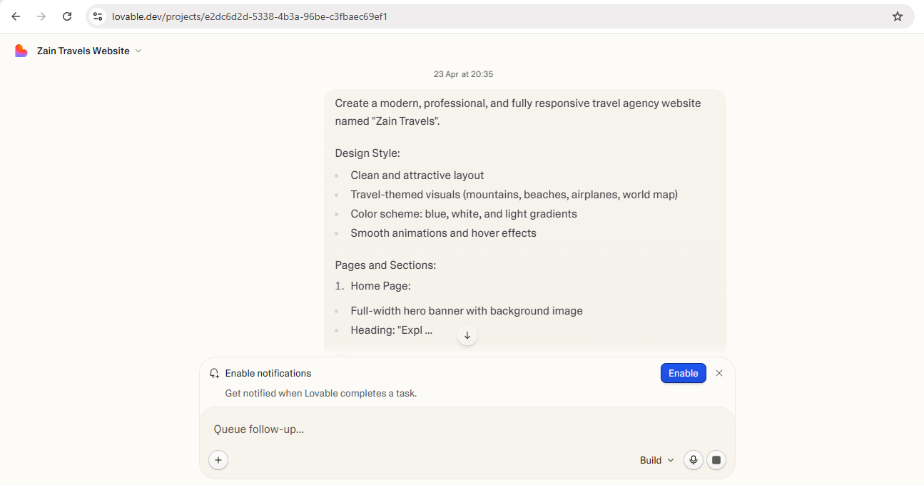
Screenshot 4:
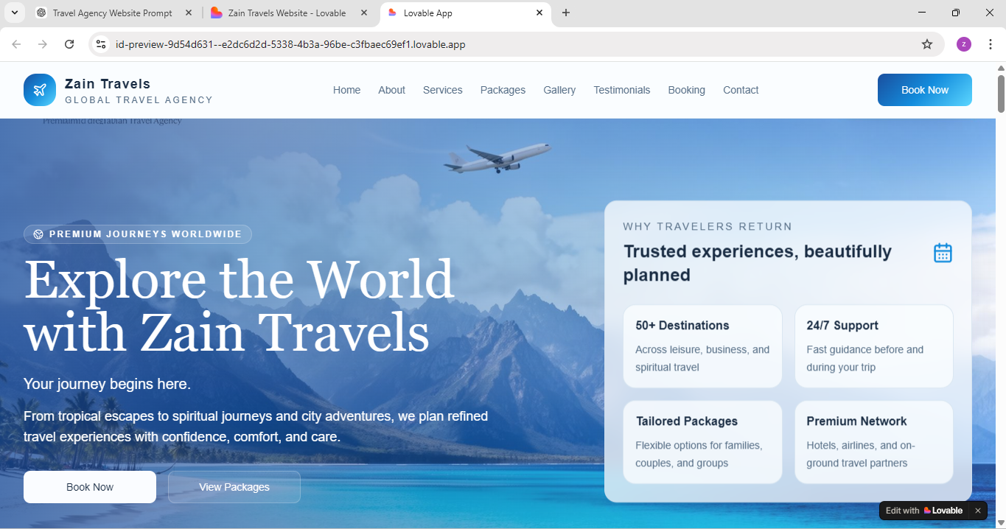
Live link:
https://id-preview-9d54d631--e2dc6d2d-5338-4b3a-96be-c3fbaec69ef1.lovable.app/

